**ABSTRACT**

The project is about simulating healing process of patients. The purpose of this simulation is analysing the number of sick people in the long run with different initial values and compare them with theoretical values. The simulation is done with machine repair method. Random values for simulation are given in description of the project for example, beds at hospital or number of hospital and etc…

The model is far beyond from reality because there is not any immunity system in system or these kinds of things. So, the system is like a small-scale reality simulation of patients with few variables.

**INTRODUCTION**

In this study the main purpose is checking whether the model is suitable with theoretical values in the long run or not. The model is a machine repair model. This study is unique because it has different randomizing values from different studies with same model.

In the following sections you can find the problem and model with more details and definitions. After descripting the problem and model according to our simulations and theoretical calculation you can find our results of simulations and comparisons of results between theoretical and model program in the long run.

**PROBLEM & MODEL DEFINITION**

We can approach the problem as a combination of machine repair problem and queueing networks. Hospital and homes are servers. We can think the patients as machines: if they get sick, they broke. There are K beds (repairmen) in hospital and N homes (again, repairmen) where patients can be serviced (repaired).

x(t) = number of sick people in hospital at time t.

* Hospital has K = 57 capacity.
* Population consists of N = 1357 individuals.
* Getting sick and coming to hospital rate of each individual (arrival rate) is λ * 0.2 = 1/1500
* Effective arrival rate is λe = λ*(N – L), this will be calculated in next section.
* Healing rate of each individual (service rate) is μ1 = 1/6.
* 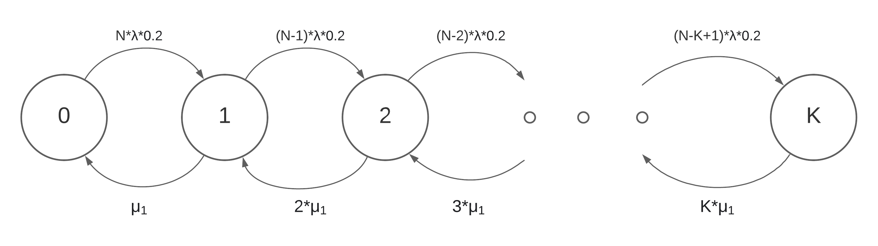

y(t) = number of sick people in their homes, those who not rejected from hospital, at time t.

* homes have N = 1357 capacity.
* Population consists of N = 1357 individuals.
* Getting sick and staying at home rate of each individual (arrival rate) is λ * 0.8 = 1/375
* Healing rate of each individual (service rate) is μ2 = 1/10.
* 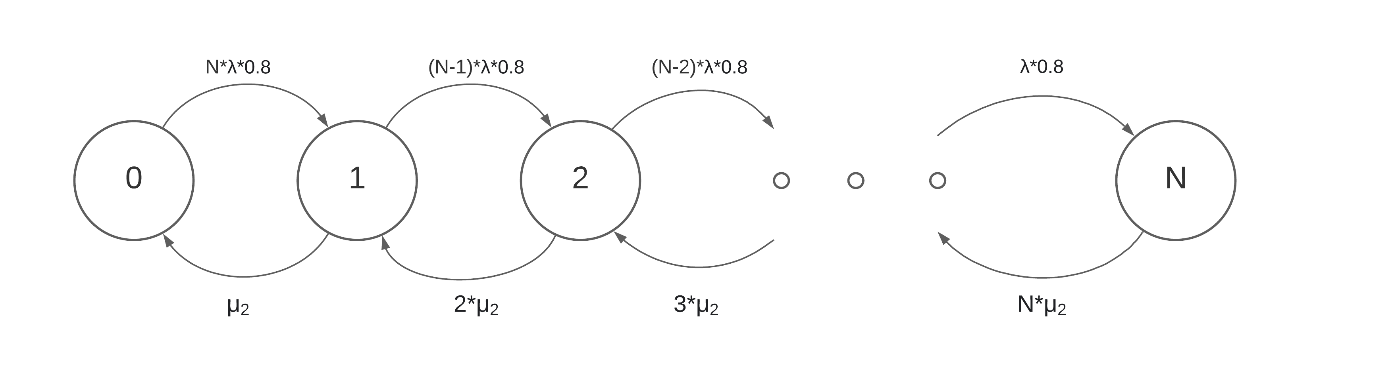

z(t) = number of sick people in their homes, those who rejected from hospital, at time t.

* homes have N = 1357 capacity.
* Population consists of N = 1357 individuals.
* Getting sick and staying at home rate of each individual (arrival rate) is   
  λ * 0.2 * (1 - $\frac{λe}{λ}$) = $\frac{1}{1500}$* 0.0040 which is quite small, we can neglect this little probability.
* Healing rate of each individual (service rate) is μ3 = 1/6*r, where r is a uniform random number between [1,2].
* 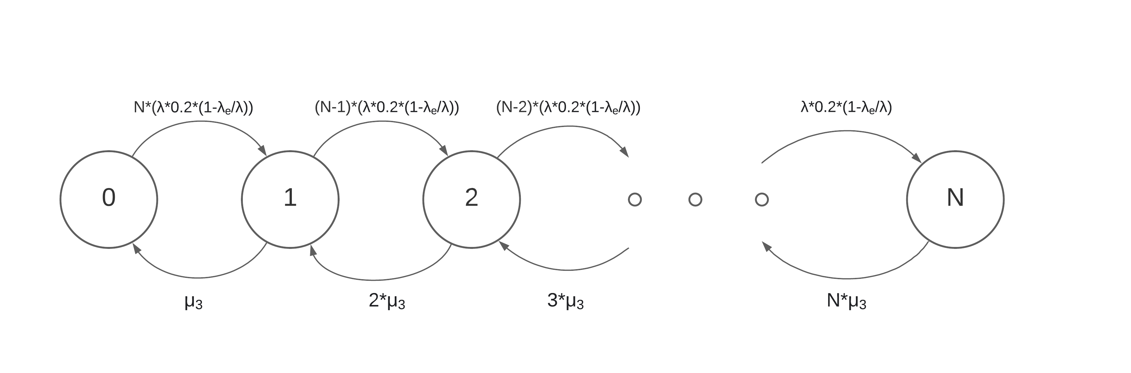

As a whole, system network can be described as follows.

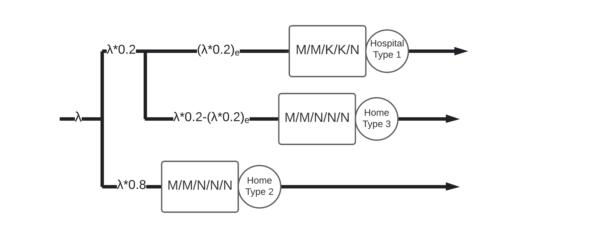

* Hospital’s Kendall notation is M/M/K/K/N, because arrival and service rates are exponential, there are K servers, system capacity is K and population size is N.
* Kendall notations of home’s are M/M/N/N/N since there are N servers and system capacity is N. Actually, we can assume that there is “definitely” a home for every patient which means c ≥ N, so we can estimate these servers as M/M/∞.

**NUMERICAL ANALYSIS**

We ran the simulation with 2 different type of limits: number of events and unit time.

** First, we simulated the model for first 50 events with three different initial conditions: hospital being empty, half full and full. Seed value was 1234. Comparison table is as follows.

One can find the theoretical results and simulation results in the zip file.

|  |  |  |  |
| --- | --- | --- | --- |
| # of patients at hospital initially | **0** | **28** | **57** |
| Long run probability of hospital being empty | 0.2222 | 0.0 | 0.0 |
| Long run probability of hospital being full | 0.0 | 0.0 | 0.0 |
| Average # of occupied beds in the hospital | 0.7778 | 15.1667 | 33.25 |
| Average # of sick people in the population | 9.8889 | 23.5 | 38.25 |
| Average proportion of sick people in the population | 0.0073 | 0.0173 | 0.0282 |
| Total average sickness time | 2.7564 | 2.8465 | 1.6964 |
| Simulation time | 9.6466 | 6.3752 | 4.5322 |

We can draw some conclusions from this table and theoretical values:

* Long run probability of hospital being empty can be calculated as follows theoretically:  
  Steady state conditions:  
  - P0 * N * λ’ = P1 * 1  
  - P1 * (N-1) * λ’ = 2 * P2 * 1- P2 * (N-2) * λ’ = 3 * P3 * 1…  
  -Pk-1 * (N-K+1) * λ’ = K * PK * 1   
  yields Pn = , and we know that = 1.  
  So, P0 = = 0.0044. K, N, λ’ = λ*0.2 and1 were given previously, (result is obtained from Python code).  
  Even though simulations’ results are close to theoretic result we can’t really expect realistic results from the simulations since runtime is too small.
* Long run probability of hospital being full can be calculated as follows theoretically:  
  PK = = 2.489e-38 $≈$ 0 (result is obtained from Python code).  
  Again, even though probabilities are consistent with theoretical value, we really cannot infer long run results from simulation.
* Average number of occupied beds in the hospital can be ca can be calculated as follows theoretically: L_hosp = $\sum_{n=0}^{K}{n P_{n}}$ = 5.4064.   
  Clearly this time theoretical and experimental values are totally irrelevant. Because system didn’t run long enough to reach steady state. On the other hand, we were expecting higher values when hospital was initially not empty. But service patients are treated very quickly in hospital and most of the events were departures.
* Average number of sick people in the population is related to the initial patient counts in hospital. But we were still expecting bigger numbers, truth be told. We were surprised with the muchness of departure events.
* Actually, average proportion of sick people in the population is found from the division of previous value to N. So, we can infer the same results as in the previous point.
* Total average sickness time can be calculated as follow theoretically:   
  0.2 / Mu1 $\frac{λe}{λ}$* + 0.8 / Mu2 + 0.2 / Mu3 * (1 - $\frac{λe}{λ}$) = 9.202268863802496.  
  Simulation results are way too short compared to theoretical value. We believe that the reason is shortness of run time of the simulation. On the other hand, the reason of the system with initially empty hospital has longer sickness time is that patients that were residing hospital in other systems recover quicklier.

So overall, we can safely arrive at the conclusion that this model was not realistic and congruent to the model. We should run the simulation for longer units of time.

** Second, we simulated the model for three different units of time with three different seeds and three different initial conditions: hospital being empty, half full and full. Seed values were 123, 456, 789.

Since there are 27 different results, we were unable to create a table like previous simulation, so we attached results in a file named “all_time_without_events.txt” under zip file.  
One can find the theoretical results and simulation results in the zip file.

* We have calculated long run probability of hospital being empty theoretically previously. It was 0.0044.  
  Mean of the simulations is 0.0048 and variance is 3.638e-06. We can safely say that simulation is really close to the theoretical value. We think that for the system ran long enough to reach its steady state.
* It’s no surprise that we get 0 when it comes to long run probability of hospital being full 27 out of 27 runs. Even if we start with full capacity, patients quickly departure and hospital never stays full.
* We have calculated the average number of occupied beds in the hospital theoretically previously. It was 5.4064.  
  Mean of the simulations is 5.4767 and variance is 0.1389. We can safely say that simulation is really close to the theoretical value. We think that for the system ran long enough to reach its steady state. Starting with initially empty or full hospital differed a bit. Mean of starting initially empty is 5.3031, initially full is 5.7545.
* Average number of sick people in the population is 40.6103 on average and has a 0.3 variance. Starting with initially empty or full hospital differed a bit. Mean of starting initially empty is 40.4124, initially full is 40.8911. This result is congruent with the previous (average number of occupied beds in the hospital) result and as expected.
* Theoretical total average sickness time was 9.2023. Simulation mean is 9.1738 with 0.005 variance. Simulation was very accurate. Again, we think that for the system ran long enough to reach its steady state. On the other hand, initially full system has a mean of 9.1595 and initially empty system has a mean of 9.1902. The reason of this tiny little difference may be the shortness of healing time of patients which resides in hospital compared to others.

**CONCLUSION**

We simulated the system with different initial conditions and with different seeds. The purpose of trying with different seeds is to have more data. Then we gathered the results, compared, and discussed them, and compared them with the theoretical values that we found.

In 50-event simulation, we could not gather meaningful data because the system is too dependent on the initial conditions and it could not get close to the steady state. In 1000,10000, and 100000-time simulations, the system reached the steady state easily (as early as 1000-time simulation), so it is less dependent on the initial conditions, and the data we got agrees with the theoretical values we found above.

All the data is in the .txt files in outputs directory. One interesting conclusion we can draw from these outputs is the fact that only 4 out of 1000 patients get rejected from hospital due to capacity restrictions. Furthermore, only 20% of the total population goes to hospital in average. So, occurrence of type 3 patients are very rare. Thus, their effect on calculations can be ignored.

**RESOURCES**

* **M. Jain, G. C. Sharma, R. S. Pundhir (2009):** SOME PERSPECTIVES OF MACHINE REPAIR PROBLEMS, link: <http://www.ije.ir/article_71867_069f8bfb60668b4a9544b6d25edd6f4b.pdf>